**HAND GESTURE MEDIA PLAYER**

**A project Report submitted**

**To**



DEPARTMENT OF

COMPUTER SCIENCE & INFORMATION TECHNOLOGY

**MASTER OF COMPUTERAPPLICATIONS**

**(MCA IV)**

***By***

**RAHUL KUMAR**

Roll No: **22072141**

**Enrollment No: GGV/22/05036**

**Under the Guidance of**

**MR. AMITESH KUMAR JHA**

DEPARTMENT OF CSIT

**GURU GHASIDAS VISHWAVIDYALAYA, BILASPUR**

Session: 2023-24

**HAND GESTURE MEDIA PLAYER**

**A project Report submitted**

**To**



DEPARTMENT OF

COMPUTER SCIENCE & INFORMATION TECHNOLOGY

**MASTER OF COMPUTERAPPLICATIONS**

**(MCA IV)**

***By***

**RAHUL KUMAR**

Roll No: **22072141**

**Enrollment No: GGV/22/05036**

**Under the Guidance of**

**MR. AMITESH KUMAR JHA**

DEPARTMENT OF CSIT

**GURU GHASIDAS VISHWAVIDYALAYA, BILASPUR**

Session: 2023-24

**CERTIFICATE OF SUPERVISOR(S)/GUIDE**

This is to certify that the work incorporated in the project “**Hand Gesture Media Player”** is a record of six-month project work assigned by our Industry/Company/Institution, successfully carried out by **RAHUL KUMAR** bearing Enrollment No. **GGV/22/05036** under my guidance and supervision for the award of Degree of **Master of Computer Applications (MCA)** of **DEPARTMENT OF COMPUTER SCIENCE & INFORMATION TECHNOLOGY, GURU GHASIDAS VISHWAVIDYALAYA, BILASPUR C.G., INDIA**.

To the best of my knowledge and belief, the report embodies the work of the candidate himself/herself and has duly been successfully completed.

**Signature of HOD**

**Dr. Ratnesh Prasad Srivastava**

**Signature of the Supervisor/Guide**

**Mr. Amitesh kumar jha**

**DELCLARATION BY THE CANDIDATE**

I, **RAHUL KUMAR**, student of IV Semester MCA, **DEPARTMENT OF COMPUTER SCIENCE & INFORMATION TECHNOLOGY, GURU GHASIDAS VISHWAVIDYALAYA, BILASPUR,** bearing Enrollment Number **GGV/22/05036,** hereby declare that the project titled “**Hand Gesture Media Player”** has been carried out by me under the guidance/supervision of **MR. AMITESH KUMAR JHA, Assistant Professors.** This project is submitted in partial fulfillment of the requirements for the award of the Degree of Master of Computer Applications (MCA) by the DEPARTMENT OF COMPUTER SCIENCE & INFORMATION TECHNOLOGY, GURU GHASIDAS VISHWAVIDYALAYA, BILASPUR during the academic year 2023-24. This report has not been submitted to any other Organization/University for any award of Diploma/Degree.

**Date:**

**Place:**

**(Signature of Candidate)**

**CERTIFICATE BY THE EXAMINER**

This is to certify that the project work entitled **"HAND GESTURE MEDIA PLAYER"** submitted by **RAHUL KUMAR** has been completed under the supervision of **MR. AMITESH KUMAR JHA,** Dept. of "Computer Science & Information Technology," GGU Bilaspur (C.G.). The project has been examined by the undersigned as a part of the examination for the award of the MCA Degree in the Dept. of "Computer Science & Information Technology" at GURU GHASIDAS CENTRAL UNIVERSITY BILASPUR (C.G.).

**"Project Examined & Approved"**

**…………………………………**

**External Examiner**

**Date-**

**…………………………………**

**Internal Examiner**

**Date-**

**……………………………………………………………**

**Signature of H.O.D. (CSIT)**

**GURU GHASIDAS CENTRAL UNIVERSITY BILASPUR (C.G.)**

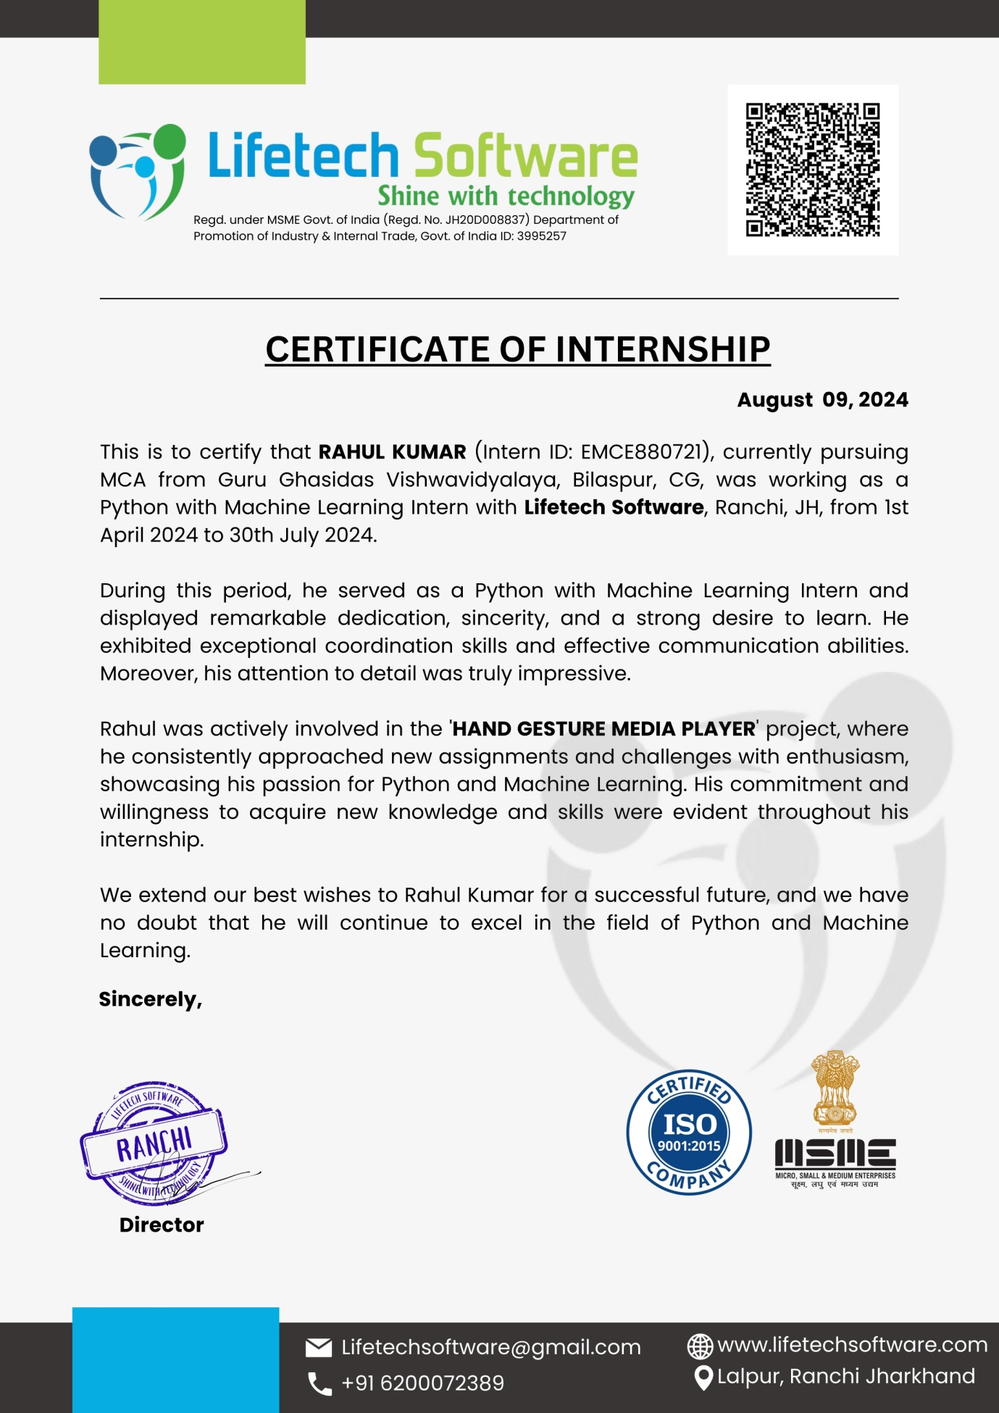

**ACKNOWLEDGEMENT**

I have great pleasure in the submission of this project report entitled “**Hand Gesture Media Player”** for **Lifetech Software** in partial fulfillment of the degree of Master of Computer Applications. While submitting this project report, I take this opportunity to thank those directly or indirectly related to the project work.

I would like to thank my guide, MR**. AMITESH KUMAR JHA**, who has provided the opportunity and organized the project for me. Without his active cooperation and guidance, it would have become very difficult to complete the task in time.

I would like to express sincere thanks to Dr. **Ratnesh Prasad Srivastava**, Head of Department of Computer Science & Information Technology, Guru Ghasidas Vishwavidyalaya, Bilaspur C.G.

Acknowledgment is due to my parents, family members, friends, and all those persons who have helped me directly or indirectly in the successful completion of the project work.

**RAHUL KUMAR**

**Table of Content**

|  |  |  |  |  |
| --- | --- | --- | --- | --- |
| No. | Heading | | | Page No. |
| 1 | Abstract and Introduction | | | 1 |
| 2 | Project Development Process Model Used (Methodology). | | | 2 |
| 3 | Project’s Process Documentation. | | | 3 |
| 4.1. | **Inception Phase** | | |  |
| 4.1.1 | Initial Description of Problem | | 3 |
| 4.1.2. | Software Requirement Specification-SRS. | |  |
|  | 4.1.2.1. | **Non-Functional Requirements** |  |
|  | • Hardware requirements. |  |
|  | • Software requirements. | 4-5 |
|  | • Communication interface |  |
|  | 4.1.2.2. | **Functional Requirements** | 6 |
|  | 4.1.2.3. | **Performance Requirements** |
| 4.1.3. | **Security features** | |
| 4.1.4. | **Reliability** | | 7 |
| 4.1.5. | Cost estimation using DFP | | 8-9 |
| 5 | **Algorithm** | | | 10 |
|  | 5.1 | Convolutional Neural Networks (CNNs) | |
|  | 5.2 | Hand Landmark Detection Model | | 11 |
|  | 5.3 | Gesture Classification Model | | 12 |
| 6 | Tools Descriptions | | | 13 |
| 7 | **Library Used** | | | 14 |
| 8 | **Dynamic Model** | | |  |
|  |  | 8.1 | Event Flow Diagram(EFD) | 16 |
| 8.2 | DFD |
|  | 8.2.1 | **Database design** | | 17 |
|  |  | 8.2.1.1 | E-R Diagram | 18 |
| 9 | **CONSTRUCTION PHASE** | | | 19 |
|  | 9.1 | Coding Language and Operating System | | 20 |
|  | 9.2 | Code description | | 21 |
| 10 | **Screenshots** | | | 23-25 |
| 11 | Testing  ReportofAlphatesting | | | 26 |
| 12 | Limitations | | | 27 |
| 13 | Scope of Application | | | 28 |
| 14 | Future Enhancement | | | 29 |
| 15 | Conclusions | | | 30 |
| 16 | Bibliography/References | | | 31 |

**List of Tables**

|  |  |  |
| --- | --- | --- |
| No. | Heading | Page No. |
| 1 | Cost estimation using DFP | 8 |

**List of Figures**

|  |  |  |
| --- | --- | --- |
| No. | Caption | Page No. |
| 1 | Convolutional Neural Networks | 10 |
| 2 | Hand Landmark detection on MediaPipe | 11 |
| 3 | Gesture Classification Model | 12 |
| 4 | Architecture of hand landmark model | 14 |
| 5 | Event Flow Diagram | 16 |
| 6 | Data Flow Diagram |
| 7 | E-R Diagram | 18 |
| 8 | Screenshots | 23 |

**LIST OFABBREVIATIONS/SYMBOLS**

|  |  |  |
| --- | --- | --- |
| No. | Abbreviation | PageNo. |
| 1 | **CNN** - Convolutional Neural Network | 10 |
| 2 | **CV** - Computer Vision | 13 |
| 3 | **PyAutoGUI** - Python Automation GUI (Graphical User Interface | 15 |
| 4 | **GUI-** Graphical User Interface | 31 |

**Abstract**

The "Hand Gesture Media Player" project represents a significant advancement in human-computer interaction by enabling users to control media playback through intuitive hand gestures. This system utilizes state-of-the-art computer vision and machine learning techniques to interpret and translate hand movements into commands for media playback functions, such as play, pause, rewind, fast-forward, and volume control.

The core of the system involves a real-time analysis of video input captured by a camera, which processes and tracks hand gestures using advanced algorithms. The gesture recognition model is trained on a diverse dataset of hand movements to ensure high accuracy and robustness across different users and environments. The system's user interface is designed to be both visually appealing and functionally straightforward, providing immediate feedback to users as they interact with the media player.

One of the primary objectives of this project is to enhance accessibility and convenience in media consumption, particularly for users who may have difficulty using traditional input devices such as keyboards or remote controls. By offering a touchless interaction method, the media player aims to create a more engaging and intuitive user experience.

The "Hand Gesture Media Player" not only showcases the potential of gesture-based interfaces but also explores the integration of cutting-edge technologies to simplify and enrich digital interactions. This project has the potential to influence a wide range of applications beyond media playback, including virtual reality environments, interactive gaming, and hands-free device control, paving the way for future innovations in user interface design.

**Index Terms:** Human Computer Interaction, Gesture Recognisation, OpenCV, PyAutoGui, Google Media Pipe, Image Processing

**INTRODUCTION**

The hand gesture media player project aims to revolutionize the way users interact with media playback systems by leveraging the power of gesture recognition technology. Traditional media control methods, such as physical remotes and touch screens, often require users to be physically present and engaged with the device, which can be inconvenient and less intuitive in certain scenarios. This project addresses these limitations by developing a gesture-based media player that allows users to control playback functions through simple hand movements, providing a more seamless and intuitive interaction experience.

**Project Development Process Model Used (Methodology).**

For developing a hand gesture media player project using Python, the Agile methodology is highly suitable due to its iterative and flexible nature. This approach allows for incremental development and frequent reassessment of project goals and requirements. Here's an outline of the project development process using Agile methodology:

1. **Conceptualization**: Begin by defining the project's vision and goals. This includes identifying the primary functionalities of the media player, such as gesture recognition for controlling playback, volume, and other features. Gather initial requirements from stakeholders and create a project backlog.
2. **Planning**: Develop a high-level plan that includes defining milestones, sprints, and deliverables. Break down the project into manageable tasks and prioritize them. Establish a timeline for each sprint, typically lasting 2-4 weeks, during which specific features or improvements will be developed.
3. **Design**: Create the system architecture and design the user interface. In the case of a hand gesture media player, this involves designing the gesture recognition module, integrating it with media controls, and ensuring a seamless user experience. Design the data flow, user interactions, and how gestures will be translated into commands.
4. **Development**: Implement the project in iterative cycles. Each sprint involves coding and developing specific features based on the prioritized tasks. For a hand gesture media player, this includes integrating Python libraries for gesture recognition (such as OpenCV or Mediapipe), developing the media player functionalities using libraries like pygame or tkinter, and testing the integration.
5. **Testing**: Conduct testing at the end of each sprint to ensure that the developed features meet the required standards and work as intended. Perform unit tests, integration tests, and user acceptance tests to identify and fix any issues. Gather feedback from stakeholders and end-users to refine the features.
6. **Review**: At the end of each sprint, review the progress and assess whether the project is on track with the goals and timeline. Conduct sprint reviews and retrospectives to discuss what went well, what needs improvement, and how to address any challenges faced.
7. **Deployment**: Once the media player reaches a stable state with all required features, prepare for deployment. This involves packaging the application, preparing documentation, and providing installation instructions. Ensure that the media player is ready for release and distribution.
8. **Maintenance and Support**: After deployment, provide ongoing support and maintenance. Address any issues reported by users, release updates, and continuously improve the media player based on user feedback and emerging needs.

**Project’s Process Documentation.**

**Initial Description of Problem**

The problem at hand involves the limitations of traditional media control methods, which rely on physical input devices such as keyboards, mice, or touch screens. These methods can be cumbersome or impractical, especially in scenarios where users' hands are occupied, such as while cooking, exercising, or engaging in other hands-on activities. The challenge is to develop a more intuitive and hands-free way of controlling media playback that allows users to interact with media players using natural hand gestures. This approach aims to enhance user convenience and experience by integrating advanced gesture recognition technology to provide seamless and efficient control without the need for physical input devices.

**Non-Functional Requirements**

**Hardware requirements**

For the hand gesture media player project, the hardware requirements typically include:

1. **Computer System**: A computer or laptop with sufficient processing power and memory to handle the gesture recognition algorithms and media playback. Recommended specifications include:
   * **Processor**: Modern multi-core CPU (e.g., Intel i5/i7 or AMD Ryzen)
   * **RAM**: At least 8GB
   * **Storage**: SSD for faster data access (minimum 256GB)
2. **Camera**: A high-resolution camera for capturing hand gestures. The quality of gesture recognition depends significantly on the camera's resolution and frame rate. Recommended options include:
   * **Webcam**: HD or Full HD webcam (1080p or higher)
   * **External Camera**: Higher-end cameras like Logitech Brio for better performance
3. **Microphone**: A good quality microphone may be needed if voice commands are also part of the control system. Options include:
   * **External Microphone**: USB or 3.5mm microphone with noise-cancellation features
4. **Input Devices**: While the primary goal is to minimize reliance on traditional input devices, you may still need:
   * **Keyboard and Mouse**: For initial setup, testing, and debugging
5. **Additional Accessories** (if necessary):
   * **Tripod or Camera Mount**: To stabilize the camera and position it correctly for optimal gesture recognition
   * **Lighting**: Proper lighting setup to enhance the camera's ability to capture clear images of hand gestures

These hardware components ensure that the system can effectively recognize and process hand gestures, providing a smooth and intuitive media control experience.

**Software requirements**

For the hand gesture media player project, the software requirements typically include:

1. **Operating System**:
   * **Windows**: Windows 10 or later
   * **macOS**: macOS 10.15 (Catalina) or later
   * **Linux**: Recent distributions like Ubuntu 20.04 or later
2. **Python**:
   * **Version**: Python 3.7 or later
3. **Libraries and Frameworks**:
   * **Computer Vision Libraries**:
     + **OpenCV**: For image processing and camera handling
     + **Mediapipe**: For hand gesture recognition and tracking
   * **Machine Learning Libraries**:
     + **TensorFlow** or **PyTorch**: For any custom gesture recognition models
   * **Media Player Libraries**:
     + **pygame** or **tkinter**: For media playback and user interface development
4. **Development Environment**:
   * **IDE/Text Editor**:
     + **VS Code**, **PyCharm**, or **Jupyter Notebook** for coding and debugging
5. **Version Control**:
   * **Git**: For version control and collaboration
6. **Dependencies Management**:
   * **pip** or **conda**: For managing Python package installations and dependencies
7. **Additional Tools** (if necessary):
   * **Docker**: For containerizing the application and ensuring consistent environments
   * **Virtual Environment**: For isolating project dependencies

**Communication interface**

For the hand gesture media player project, the communication interface is crucial for enabling interaction between the gesture recognition system and the media player functionalities. Here’s a breakdown of the communication interfaces you might use:

1. **User Interface (UI)**:
   * **Graphical User Interface (GUI)**: Developed using libraries like tkinter, PyQt, or Kivy to provide users with visual controls and feedback related to media playback and gesture recognition.
   * **On-Screen Display**: To show real-time feedback or notifications about recognized gestures and media status.
2. **Gesture Recognition Interface**:
   * **API Integration**: If using external libraries or services for gesture recognition, ensure they have APIs that can be integrated with your Python application. For instance, Mediapipe provides APIs for accessing gesture recognition data.
   * **Data Streams**: Handling real-time data streams from the camera and processing it to recognize and interpret gestures.
3. **Media Control Interface**:
   * **Media Playback Library**: Interfaces for controlling media playback (e.g., pygame for media playback functions or direct control interfaces for systems like VLC or custom media players).
   * **Command Mapping**: Mapping recognized gestures to media commands such as play, pause, volume control, and skipping tracks.
4. **External Devices Communication**:
   * **Camera Interface**: Ensuring proper communication with the camera hardware to capture video input for gesture recognition.
   * **Microphone Interface** (if applicable): Communicating with the microphone for any voice command features.
5. **Feedback Mechanism**:
   * **Visual Feedback**: Displaying visual cues or indicators on the GUI to inform users about the status of their gestures or media playback.
   * **Auditory Feedback**: Optionally providing sound alerts or notifications to confirm gesture recognition or changes in media status.
6. **Networking (if applicable)**:
   * **Local Network Communication**: If the media player is to be controlled remotely, establishing a network communication protocol (e.g., HTTP, WebSocket) to handle remote commands and feedback.

**Functional Requirements**

The hand gesture media player project must incorporate several key functional requirements to ensure its effectiveness and usability. Firstly, the system needs to provide accurate real-time gesture recognition and interpretation, translating hand movements into specific media commands such as play, pause, and volume adjustments. The media control functionalities should include playback controls, volume adjustment, and track navigation, all operable through gestures. The user interface (UI) must deliver visual feedback, confirming recognized gestures and displaying the current media status, while ensuring responsive and intuitive design. Integration with the camera is essential for capturing high-resolution video input for gesture tracking, and the system must handle camera calibration to maintain accuracy. Error handling mechanisms should address any issues in gesture recognition and system performance, with fallback options or error messages as needed. The system must operate with low latency and efficient resource usage to ensure smooth performance. Customization options should allow users to personalize gestures and settings according to their preferences. Additionally, the media player must be compatible with various media formats and operating systems and provide comprehensive user documentation and support to assist with any issues. These requirements collectively aim to deliver a seamless and user-friendly gesture-controlled media playback experience.

**Performance Requirements**

The performance requirements for the hand gesture media player project are essential to ensure a smooth and effective user experience. The system must achieve low latency, processing gestures and translating them into media commands with minimal delay, ideally under 100 milliseconds, to maintain responsiveness. Real-time processing capabilities are crucial, requiring the gesture recognition algorithms to handle high-resolution video feeds efficiently and execute tasks swiftly. High accuracy in gesture recognition is a must, with a target of at least 95% accuracy to reduce command execution errors. The application should be optimized for resource efficiency, avoiding excessive consumption of CPU, GPU, and memory to prevent system slowdowns. It should also be scalable, able to handle varying workloads and adapt to different system specifications. Stability is key, with the media player maintaining consistent operation during extended use and avoiding crashes or performance degradation. Compatibility across different operating systems and hardware configurations is necessary to ensure reliable performance for a broad user base. Additionally, the system must include robust error handling and recovery mechanisms to address issues such as gesture misinterpretation or camera disconnection, providing users with clear error messages and allowing for quick resumption of normal operation. Meeting these performance requirements will ensure that the hand gesture media player delivers a high-quality, responsive, and reliable experience.

**Security features**

To ensure the security of the hand gesture media player project, several key features must be integrated. Data protection is essential, involving the use of encryption, such as AES, to safeguard sensitive user information and secure storage practices to restrict access. Communication should be protected with secure protocols like HTTPS and TLS to prevent interception of data. If the media player involves user accounts, robust user authentication mechanisms and permissions management must be implemented to control access to system components. System integrity is maintained through regular code reviews and updates to address vulnerabilities and follow secure coding practices. Privacy considerations include minimizing data collection, obtaining user consent, and ensuring transparency about data use. Network security measures, such as firewalls and intrusion detection systems, should be employed to guard against unauthorized access and potential attacks. Additionally, secure development practices, including vulnerability assessments and penetration testing, are crucial for identifying and addressing security risks. Finally, error handling should be designed to prevent the exposure of sensitive information that could be exploited. These security features collectively ensure that the hand gesture media player operates safely, protecting user data and maintaining system integrity.

**Reliability**

Ensuring the reliability of the hand gesture media player is essential for delivering a consistent and dependable user experience. The system must be robust, performing reliably without crashes or unexpected behavior through extensive testing and validation. Effective error handling is crucial, with the ability to manage issues gracefully by providing informative error messages and allowing users to recover quickly. Fault tolerance is also important, with redundancy in critical components to prevent single points of failure. Consistent performance must be maintained by efficiently managing system resources, avoiding performance degradation over time. Regular updates and maintenance are necessary to address bugs, enhance functionality, and adapt to evolving needs. Additionally, providing comprehensive user support and documentation helps users resolve issues and understand the system’s functionality. By focusing on these reliability aspects, the hand gesture media player will ensure stable and dependable operation, enhancing user satisfaction.

**Cost estimation using DFP**

The Detailed Function Point (DFP) method is used for estimating the cost of a software project based on its functionality and complexity. To apply DFP, we need to follow these steps:To estimate the effort and cost of a software project, you can follow a systematic approach involving function points. Begin by identifying and counting the function points based on five types of user functions: External Inputs (EI), External Outputs (EO), External Inquiries (EQ), Internal Logical Files (ILF), and External Interface Files (EIF). Each function type is assessed to determine its count. Next, assign complexity weights to each function based on its characteristics—these weights can be low, average, or high. Using these weights, calculate the Unadjusted Function Points (UFP) by multiplying the count of each function type by its complexity weight and summing the results.

After obtaining the UFP, determine the Value Adjustment Factor (VAF) by evaluating general system characteristics (GSCs) such as performance, usability, and other relevant factors. This adjustment reflects the impact of these characteristics on the overall function points. Finally, calculate the Adjusted Function Points (AFP) by applying the VAF to the UFP. With the AFP in hand, estimate the effort and cost of the project by converting the function points into person-hours using historical data or industry standards, and then translate these hours into cost. This structured approach ensures a comprehensive and quantitative method for project estimation.

**Step-by-Step Example for the Hand Gesture Media Player Project**

**Step 1: Identify and Count Function Points**

* **External Inputs (EI)**:
  + User gestures (e.g., play, pause, volume up/down, next track, previous track) - 5 inputs.
* **External Outputs (EO)**:
  + Visual feedback for each gesture - 5 outputs.
* **External Inquiries (EQ)**:
  + Interactive gesture recognition (e.g., confirming recognized gestures) - 1 inquiry.
* **Internal Logical Files (ILF)**:
  + User settings and configurations - 1 file.
* **External Interface Files (EIF)**:
  + Pre-trained gesture models (used for reference) - 1 file.

**Step 2: Assign Complexity Weights**

**Table no. 1- Cost estimation using DFP**

|  |  |  |  |
| --- | --- | --- | --- |
| **Function Type** | **Count** | **Complexity** | **Weight** |
| External Inputs | 5 | Average | 4 |
| External Outputs | 5 | Average | 5 |
| External Inquiries | 1 | Average | 4 |
| Internal Logical Files | 1 | Low | 7 |
| External Interface Files | 1 | Low | 5 |

**Step 3: Calculate Unadjusted Function Points (UFP)**

UFP=(5×4)+(5×5)+(1×4)+(1×7)+(1×5)=20+25+4+7+5=61

**Step 4: Determine Value Adjustment Factor (VAF)**

Suppose the VAF is determined to be 1.1 based on the system's general characteristics.

**Step 5: Calculate Adjusted Function Points (AFP)**

AFP=UFP×VAF=61×1.1=67.1

**Step 6: Estimate Effort and Cost**

Suppose the industry standard is 20 person-hours per function point and the average cost per person-hour is $50.

Effort=AFP×20=67.1×20=1342 person-hours

The cost estimation for the hand gesture media player project, based on the Detailed Function Point method, is approximately $67,100. This estimation accounts for the complexity and functionality of the system, ensuring a comprehensive understanding of the project's scope and required resources.

**ALGORITHM**

**Convolutional Neural Networks (CNNs)**

Convolutional Neural Networks (CNNs) are a specialized type of deep learning algorithm designed for analyzing visual data, such as images and videos. They excel in tasks like image classification, object detection, and image segmentation due to their ability to automatically learn spatial hierarchies of features from input data. CNNs operate through a series of layers: **convolutional layers** apply filters to detect specific features like edges and textures; **activation functions**, such as Rectified Linear Units (ReLU), introduce non-linearity to help the network learn complex patterns; and **pooling layers** reduce the spatial dimensions of feature maps, which decreases computational complexity and helps prevent overfitting. **Fully connected layers** then aggregate the learned features to make predictions, such as class probabilities. The network may also use **dropout layers** for regularization, reducing the risk of overfitting by randomly deactivating neurons during training. CNNs have transformed computer vision by automating feature extraction and providing high accuracy in tasks such as image recognition and object detection. Their ability to learn and identify complex patterns makes them a cornerstone in modern visual recognition technologies.

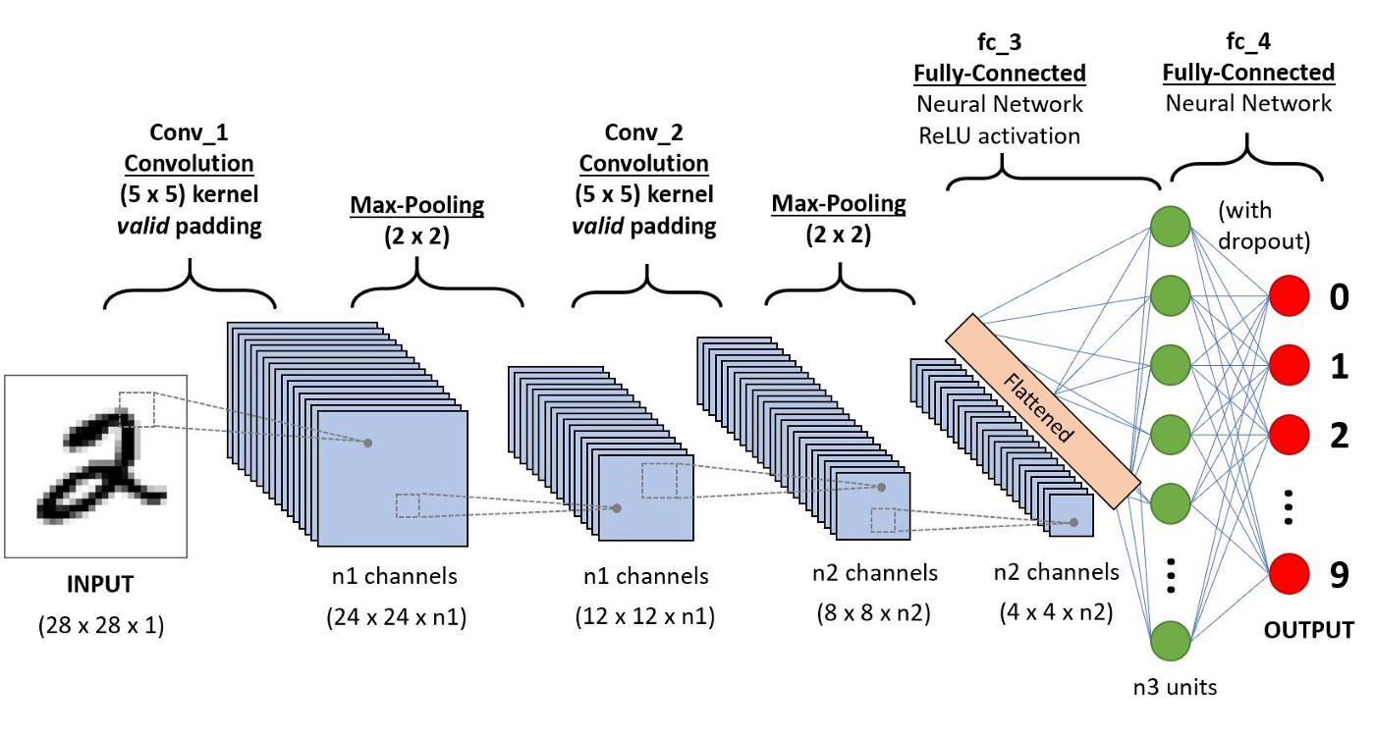

Fig1-Convolutional Neural Networks

**Hand Landmark Detection Model**

The landmark detection model is a specialized neural network designed to identify and locate key points or landmarks on an object, such as a human hand, within an image. In the context of hand gesture recognition, this model processes input images to predict the positions of critical points on the hand, including fingertips, joints, and the palm. The model typically utilizes Convolutional Neural Networks (CNNs) to extract relevant features from the image, which are then used to pinpoint the precise locations of these landmarks.

The process involves first converting the image into a format suitable for analysis, such as transforming it to RGB. The model then applies a series of convolutional operations to detect various features and patterns. It follows this with a regression layer that outputs the coordinates of the hand landmarks. This output is crucial for subsequent gesture recognition, as the relative positions and movements of these landmarks are used to interpret specific hand gestures. The landmark detection model enables accurate tracking of hand positions and gestures in real-time, providing a foundational technology for gesture-based interfaces and applications.

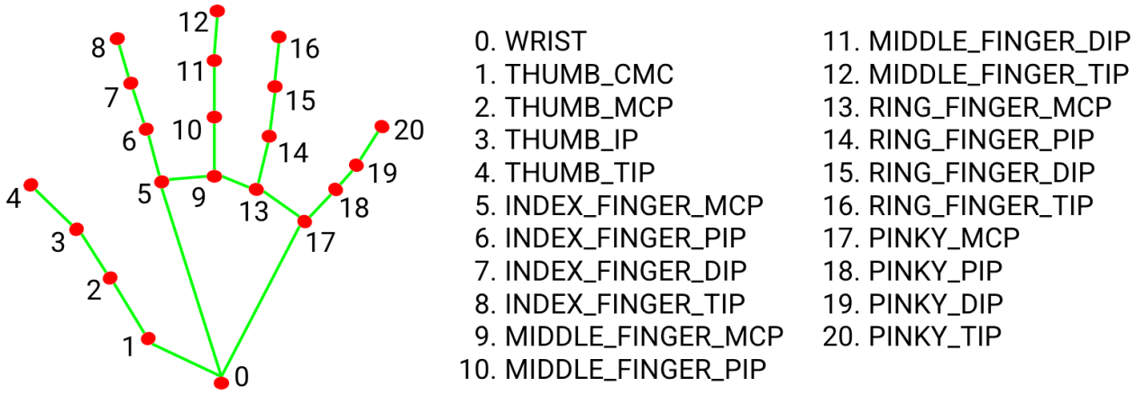**Fig 2 -** Hand Landmark detection on MediaPipe

**Gesture Classification Model (Custom or Heuristic-Based)**

The gesture classification model is crucial for interpreting hand gestures based on the landmarks detected on the hand. This model can either be custom-built using machine learning techniques or based on heuristic rules. In a custom gesture classification model, the system is trained on a labeled dataset of hand gestures, where machine learning algorithms learn to recognize different gestures by analyzing patterns in landmark coordinates. This approach involves collecting gesture data, extracting features such as distances and angles between landmarks, and training a model to classify gestures accurately. On the other hand, a heuristic-based approach relies on predefined rules and conditions to identify gestures. This method uses specific criteria, such as changes in distances between landmarks or movement trajectories, to classify gestures without the need for extensive training data. Both approaches aim to translate hand gestures into actionable commands or responses, with custom models offering the potential for greater accuracy through learning, while heuristic models provide a simpler, rule-based solution.

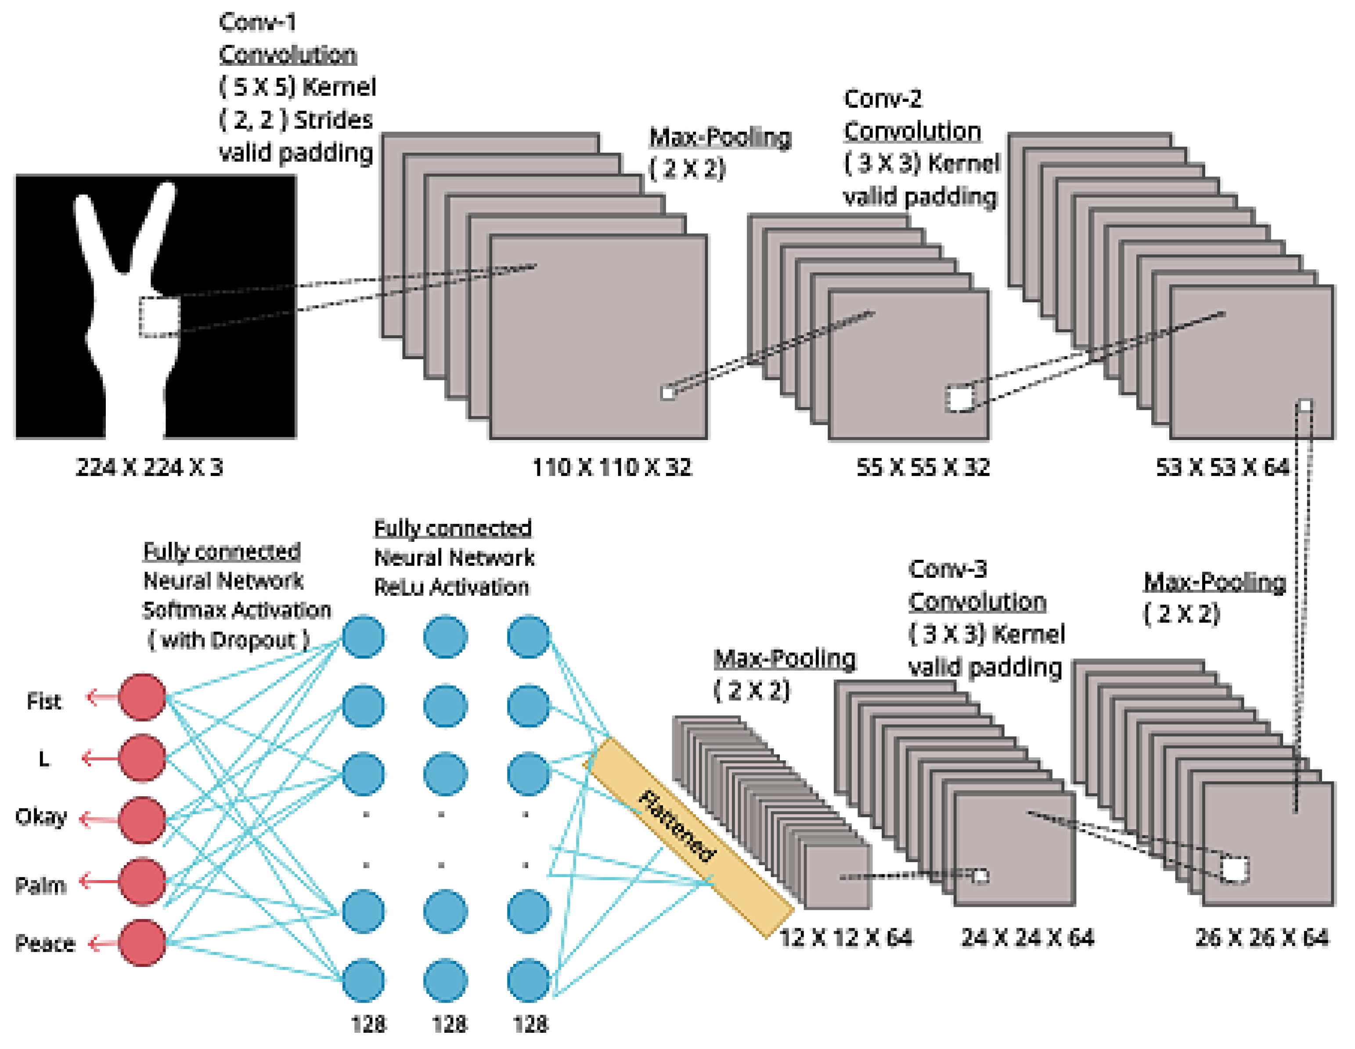

Fig 3-Gesture Classification Model

**Tools Descriptions**

Here’s a description of the tools that might be used in the hand gesture media player project:

1. **Python**:
   * **Description**: A high-level, versatile programming language used for developing the core functionality of the media player, including gesture recognition, media control, and user interface.
   * **Features**: Easy-to-read syntax, extensive libraries, and strong community support.
2. **OpenCV**:
   * **Description**: An open-source computer vision library used for processing and analyzing video input from the camera. It helps with image capturing, pre-processing, and gesture detection.
   * **Features**: Real-time image processing, support for various image formats, and powerful algorithms for computer vision tasks.
3. **Mediapipe**:
   * **Description**: A framework developed by Google for building multimodal machine learning pipelines, particularly useful for hand gesture recognition. It provides pre-trained models for gesture detection and tracking.
   * **Features**: High accuracy in gesture recognition, real-time performance, and easy integration with Python.
4. **Pygame**:
   * **Description**: A set of Python modules designed for writing video games, which can also be used for handling media playback and user interface elements.
   * **Features**: Simple media handling, support for various multimedia formats, and easy-to-use APIs for creating interactive applications.
5. **Git**:
   * **Description**: A version control system used for managing changes to the project’s codebase, enabling collaboration, and tracking development progress.
   * **Features**: Branching and merging, history tracking, and integration with various platforms like GitHub and GitLab.
6. **VS Code/PyCharm**:
   * **Description**: Integrated Development Environments (IDEs) that facilitate coding, debugging, and project management.
   * **Features**: Code editing, debugging tools, project navigation, and extensions for additional functionality.
7. **Docker** (optional):
   * **Description**: A platform for containerizing applications, ensuring consistent development and deployment environments.
   * **Features**: Containerization, environment isolation, and ease of deployment.

**Library used**

**CV2 (OpenCV)**:

OpenCV, commonly known as cv2 in its Python package form, is an open-source computer vision and machine learning software library. It is designed to provide a common infrastructure for computer vision applications and to accelerate the use of machine perception in commercial products. OpenCV contains more than 2,500 optimized algorithms that can be used for various purposes such as detecting and recognizing faces, identifying objects, classifying human actions in videos, tracking camera movements, tracking moving objects, extracting 3D models of objects, stitching images together to produce a high-resolution image of an entire scene, finding similar images from an image database, removing red-eye, following eye movements, recognizing scenery, and establishing markers to overlay it with augmented reality, among many others. OpenCV’s extensive functionality makes it a key tool in projects involving real-time computer vision and image processing, such as the hand gesture media player project, where it is used to capture and process video frames from the camera, enabling accurate and efficient gesture recognition.

**Mediapipe**

Mediapipe is a versatile framework developed by Google that simplifies the development of machine learning pipelines, particularly those related to multimodal perception. It is highly efficient for real-time applications, leveraging optimized performance across various platforms, including mobile and desktop environments. Mediapipe provides pre-built solutions for common tasks such as hand and pose tracking, facial landmark detection, and object detection, significantly reducing the development effort required to implement these functionalities from scratch. In the context of the hand gesture media player project, Mediapipe is used to detect and track hand gestures in real-time, utilizing its advanced computer vision and machine learning algorithms to interpret user hand movements accurately. This enables the system to recognize specific gestures and translate them into media control commands, providing an intuitive and hands-free user interaction experience. Mediapipe’s robustness, real-time performance, and ease of integration with Python make it an invaluable tool for enhancing the gesture recognition capabilities of the media player.

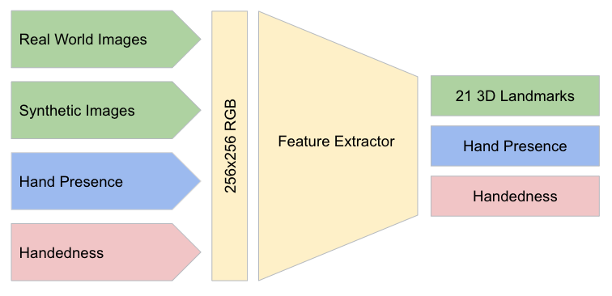

Fig 4- Architecture of hand landmark model

**Pyautogui**:

PyAutoGUI is a Python library designed for automating graphical user interface (GUI) tasks by simulating mouse movements, clicks, and keyboard presses. It allows developers to control the mouse and keyboard programmatically, enabling the automation of repetitive tasks, testing of user interfaces, or controlling applications without direct manual input. PyAutoGUI also provides functionalities for taking screenshots, locating images on the screen, and handling basic GUI events, making it a versatile tool for creating scripts that interact with the computer’s interface. In the hand gesture media player project, PyAutoGUI plays a crucial role in translating recognized hand gestures into actionable media control commands. For example, when a user performs a gesture to play or pause a video, PyAutoGUI can simulate the corresponding keyboard press or mouse click to control the media player accordingly. This allows for a seamless and intuitive user experience where media playback can be controlled hands-free through gestures. PyAutoGUI's ease of use and ability to interact with various applications make it an essential component for implementing the gesture-based control system in this project.

**Time**

The time module in Python provides various time-related functions, enabling developers to work with time and perform operations such as pausing the execution of a program, measuring the duration of code execution, and manipulating time values. Key functions include time.sleep(), which pauses the program for a specified number of seconds, and time.time(), which returns the current time in seconds since the epoch (usually January 1, 1970). Additionally, time.strftime() allows formatting time into readable strings, while time.strptime() parses strings into time objects. In the hand gesture media player project, the time module is used to manage the timing of operations and ensure smooth interaction between gesture detection and media control. For instance, time.sleep() can introduce short delays to prevent the system from overloading with continuous gesture recognition processing, providing a more natural and responsive user experience. Moreover, time.time() can help measure the duration of gesture detection and command execution, aiding in performance optimization and ensuring that gestures are recognized and acted upon promptly. The time module's simplicity and versatility make it a fundamental tool for managing temporal aspects within the project.

**Event Flow Diagram (EFD):**

An Event Flow Diagram (EFD) visually represents the sequence of events in a system and the interactions between them. For the hand gesture media player project, an EFD can help illustrate the flow from gesture detection to media control execution.

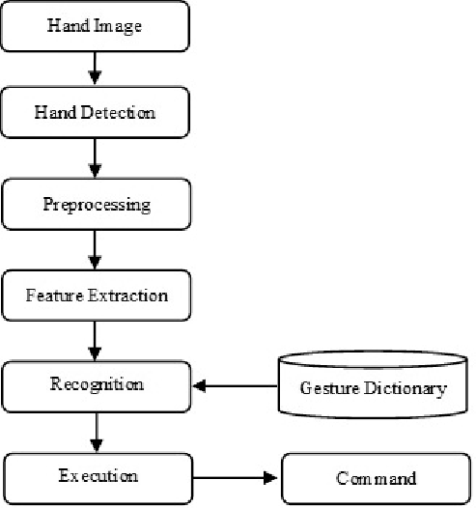

Fig 5- Event Flow Diagram

**DFD**

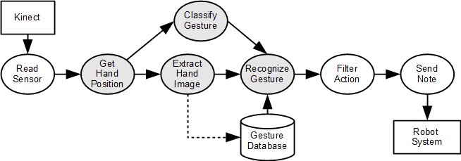

Fig 6- Data Flow Diagram

**Database design**

The database design for the hand gesture media player project includes several tables to manage user information, settings, gesture models, and logs of gesture interactions. The **Users** table stores user-specific data, such as unique user IDs, usernames, password hashes, and email addresses. The **User Settings** table, linked to the Users table, holds individual settings for each user, like preferred volume levels and other media player configurations, with fields for setting names and values. The **Gestures** table contains details about the hand gestures, including gesture IDs, names, and paths to the model files used for recognizing each gesture. To log interactions, the **Gesture Logs** table records each recognized gesture, associating it with the user who performed it and the corresponding command executed, along with a timestamp for when the gesture was recognized. This table is linked to both the Users and Gestures tables. These relationships allow for efficient data management and retrieval, supporting user authentication, personalized settings, accurate gesture recognition, and comprehensive logging of user interactions with the media player.

**E-R Diagram**

The Entity-Relationship (E-R) Diagram for the hand gesture media player project illustrates the key components and their relationships. It includes four main entities: **User**, **UserSettings**, **Gesture**, and **GestureLog**. The **User** entity stores user details and is connected to **UserSettings** for managing personalized settings. The **Gesture** entity contains information about recognized hand gestures and is linked to **GestureLog**, which records user interactions with gestures, including the commands executed and timestamps. This diagram provides a clear view of how user information, settings, gestures, and interaction logs are related and managed within the system.

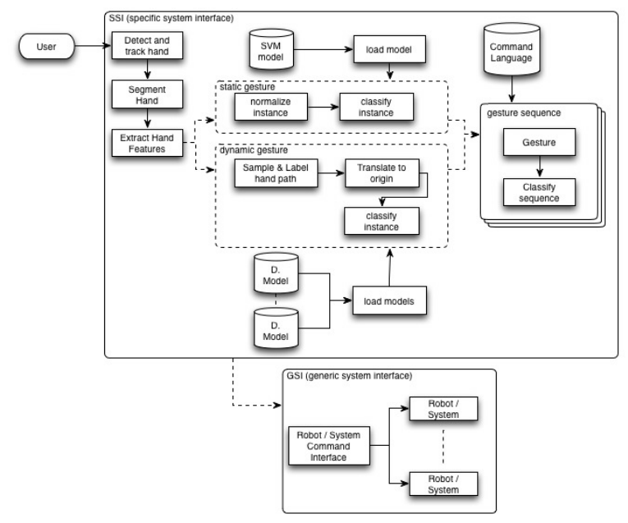

Fig 7- E-R Diagram

**CONSTRUCTION PHASE**

**CASE Tools used to design**

For designing the hand gesture media player project, several CASE (Computer-Aided Software Engineering) tools can be used to support various stages of development, including modeling, documentation, and analysis. Here are some commonly used CASE tools for designing such a project:

1. **Microsoft Visio**:
   * **Usage**: Ideal for creating flowcharts, data flow diagrams (DFDs), entity-relationship diagrams (ERDs), and other visual representations of system architecture. It provides a range of templates and shapes for designing and documenting the system.
2. **Lucidchart**:
   * **Usage**: A web-based tool for creating diagrams such as ER diagrams, flowcharts, and process maps. It supports collaborative design, allowing multiple team members to work on the same diagram in real-time.
3. **draw.io (diagrams.net)**:
   * **Usage**: A free, web-based diagramming tool that offers a variety of diagram types, including E-R diagrams, flowcharts, and network diagrams. It’s useful for creating and sharing detailed system designs.
4. **UML Modeling Tools (e.g., StarUML, Enterprise Architect)**:
   * **Usage**: These tools are used for creating Unified Modeling Language (UML) diagrams, such as class diagrams, sequence diagrams, and use case diagrams. They are valuable for modeling system architecture and behavior.
5. **MySQL Workbench**:
   * **Usage**: A database design tool that provides visual tools for designing, modeling, and managing databases. It supports the creation of ER diagrams and schema design, which is crucial for structuring the database for the project.
6. **Adobe XD or Figma**:
   * **Usage**: These tools are useful for designing user interfaces and creating interactive prototypes. They help in visualizing the user experience and interactions within the media player application.
7. **Jira or Trello**:
   * **Usage**: Project management tools that help in tracking tasks, managing project workflows, and collaborating with team members. They can be integrated with design tools to keep track of development progress and requirements.

**Coding Language and Operating System**

**Python**:

Python is the primary programming language used for developing the hand gesture media player project. It is chosen for its readability, simplicity, and extensive support for libraries and frameworks that are crucial for the project. Python's versatility makes it ideal for rapid development and prototyping. It supports various libraries such as OpenCV (cv2) for image processing, Mediapipe for gesture recognition, and PyAutoGUI for automating GUI interactions. Its rich ecosystem and strong community support contribute to its suitability for tasks involving computer vision and automation.

**Operating System**

**Windows**:

Windows is the operating system used for developing and running the hand gesture media player project. It is chosen due to its widespread use and compatibility with a variety of software tools and libraries required for the project. Windows supports the necessary Python libraries and tools, including OpenCV, Mediapipe, and PyAutoGUI, which are crucial for handling real-time gesture recognition and media control automation. Additionally, Windows provides a user-friendly interface and robust development environment, making it a preferred choice for many developers working on GUI-based applications.

**Alternatively**: **Linux**:

**Explanation**: Linux could also be used as an operating system for this project, particularly for those who prefer open-source environments or need to deploy the application on servers or other Linux-based systems. Linux supports Python and the required libraries, and it provides a stable and flexible development environment. It’s also often used for its efficiency and customization options, which can be beneficial for optimizing performance and handling real-time processing tasks.

**Code description**

The code for the hand gesture media player is designed to integrate several components, including video capture, gesture recognition, and media control automation. Below is a high-level description of the key parts of the code:

1. **Import Libraries**:

python

Copy code

import cv2

import mediapipe as mp

import pyautogui

import time

* + **cv2**: Used for video capture and image processing.
  + **mediapipe**: Provides hand gesture recognition capabilities.
  + **pyautogui**: Handles automation of media control commands.
  + **time**: Manages delays and timing for smooth execution.

1. **Initialize Components**:

python

Copy code

mp_hands = mp.solutions.hands

hands = mp_hands.Hands()

mp_drawing = mp.solutions.drawing_utils

* + **mp_hands**: Accesses Mediapipe's hand gesture recognition module.
  + **hands**: Initializes the hand gesture recognition model.
  + **mp_drawing**: Provides utilities for drawing hand landmarks on the screen.

1. **Capture Video**:

python

Copy code

cap = cv2.VideoCapture(0)

* + Opens the default camera for video capture.

1. **Process Video Frames**:

python

Copy code

while True:

ret, frame = cap.read()

if not ret:

break

frame_rgb = cv2.cvtColor(frame, cv2.COLOR_BGR2RGB)

results = hands.process(frame_rgb)

* + Reads frames from the video capture.
  + Converts frames to RGB format for processing by Mediapipe.
  + Processes the frames to detect hand gestures.

1. **Detect and Recognize Gestures**:

python

Copy code

if results.multi_hand_landmarks:

for landmarks in results.multi_hand_landmarks:

mp_drawing.draw_landmarks(frame, landmarks, mp_hands.HAND_CONNECTIONS)

# Implement gesture recognition logic here

* + Detects hand landmarks in the frame.
  + Draws landmarks on the frame for visualization.
  + Contains a placeholder for recognizing specific gestures based on landmark positions.

1. **Execute Media Commands**:

python

Copy code

if gesture_recognized == 'play':

pyautogui.press('playpause')

elif gesture_recognized == 'volume_up':

pyautogui.press('volumeup')

elif gesture_recognized == 'volume_down':

pyautogui.press('volumedown')

* + Executes commands based on recognized gestures.
  + Uses PyAutoGUI to simulate keyboard presses for media control.

1. **Display and Handle Exit**:

python

Copy code

cv2.imshow('Hand Gesture Media Player', frame)

if cv2.waitKey(1) & 0xFF == ord('q'):

break

* + Displays the processed video frame with gestures.
  + Checks for a quit command (e.g., pressing 'q') to exit the application.

1. **Release Resources**:

python

Copy code

cap.release()

cv2.destroyAllWindows()

* + Releases the video capture object and closes all OpenCV windows when the application exits.

**Screenshots**

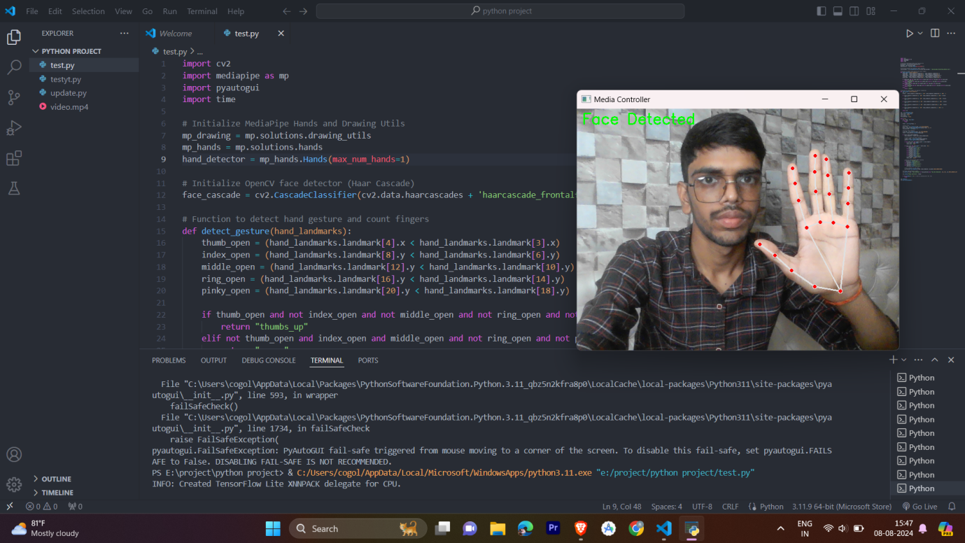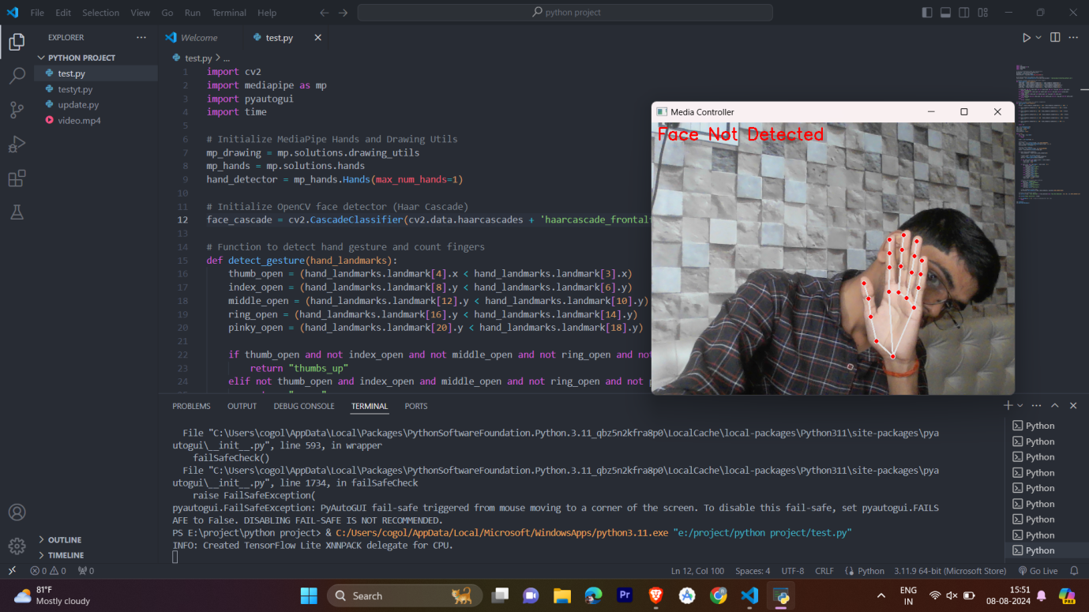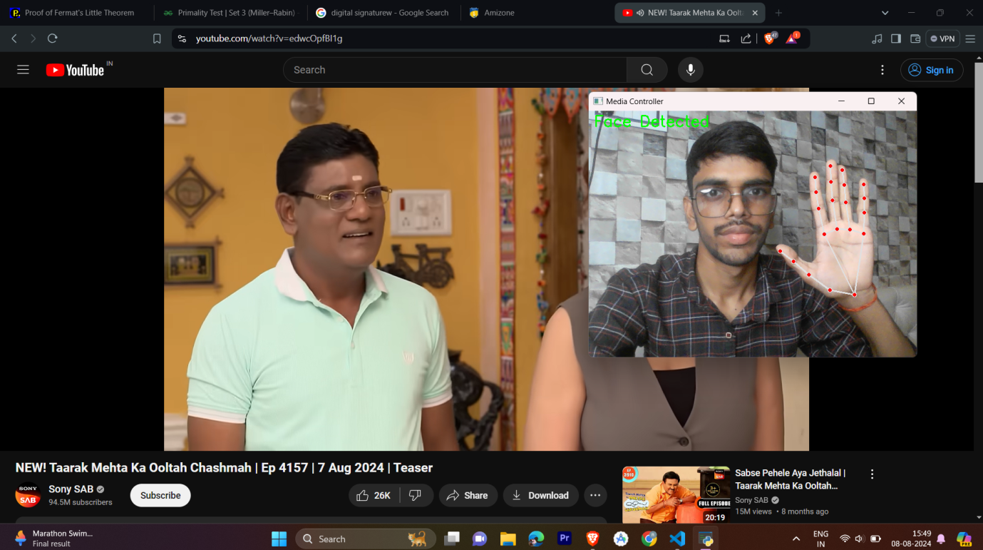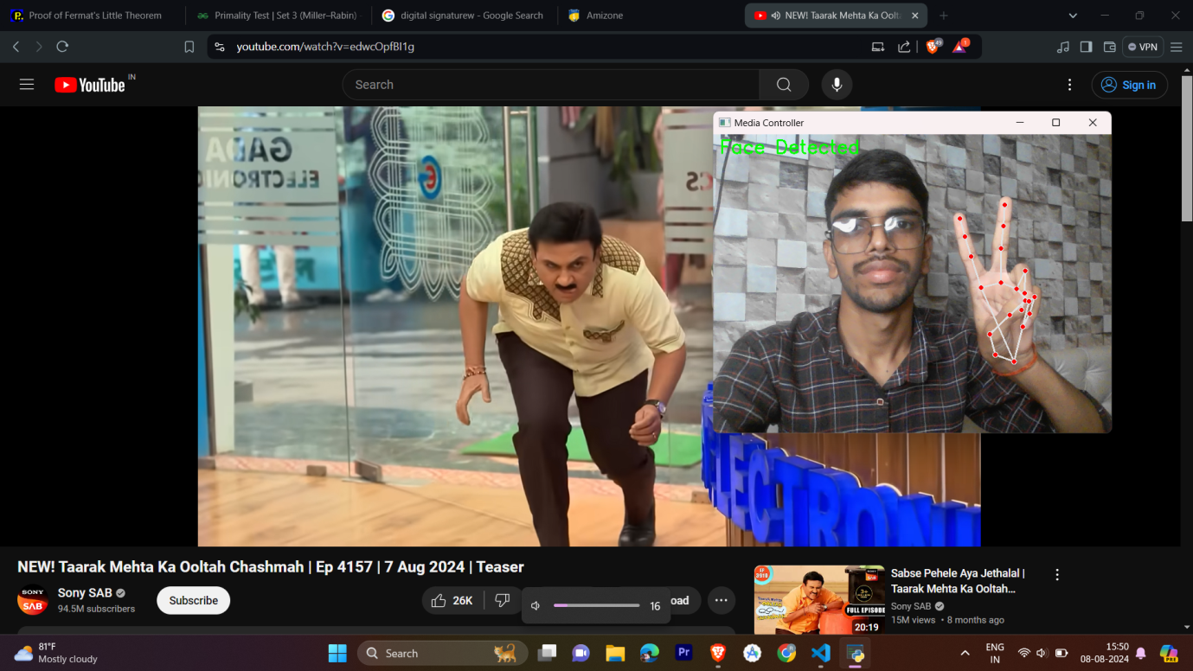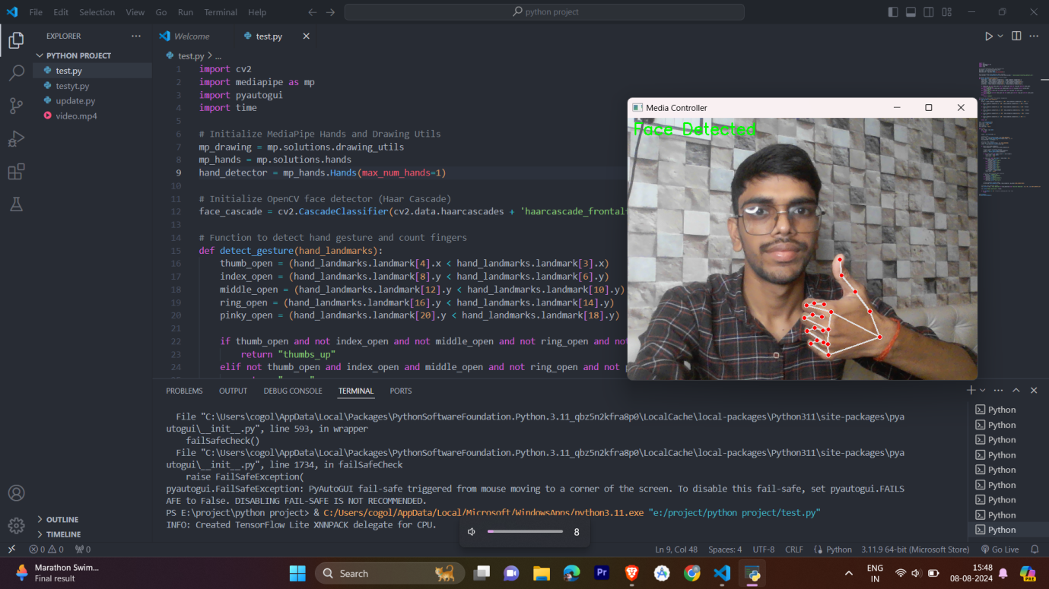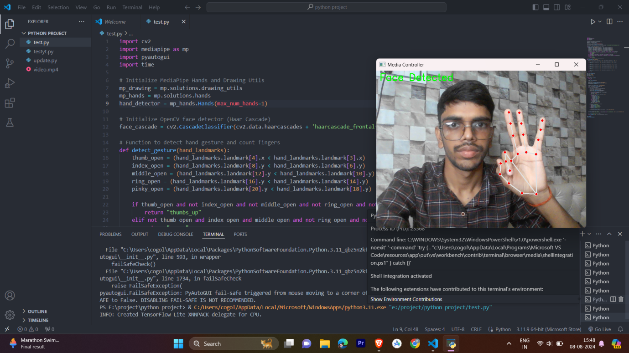

**TRANSITION PHASE**

TESTING

Testing for the hand gesture media player project involves a multi-faceted approach to ensure the system operates correctly and efficiently.

**Unit Testing** focuses on verifying that individual components and functions work as intended. This includes testing the accuracy and reliability of the Mediapipe gesture recognition system to ensure it correctly identifies various hand gestures. It also involves checking if PyAutoGUI commands accurately simulate media control actions, such as play, pause, and volume adjustments. Additionally, unit testing assesses whether video frames are captured, processed, and displayed without significant errors or delays. Automated scripts and manual testing methods are used to evaluate each function independently.

**Integration Testing** aims to confirm that different components of the system work together as expected. This includes testing the integration between gesture recognition and media control to ensure that detected gestures correctly trigger the corresponding media commands. It also involves checking that data flows smoothly between video capture, gesture recognition, and media control modules without loss or corruption. End-to-end tests are performed to validate the interactions and data handling across combined components.

**System Testing** evaluates the complete functionality and performance of the system in a real-world environment. This includes running comprehensive tests to ensure the entire system—from video capture through gesture recognition to media control—functions seamlessly. Performance testing assesses responsiveness and processing speed, ensuring that gesture recognition and media control actions occur in real-time without noticeable lag. Various scenarios and user inputs are tested to cover different use cases and conditions.

**User Acceptance Testing (UAT)** ensures that the system meets user requirements and expectations. Usability testing evaluates the ease of use and intuitiveness of the gesture control system, gathering feedback on the accuracy of gesture recognition and the effectiveness of media control commands. Error handling is also tested to see how the system manages incorrect gestures or unexpected inputs, ensuring that users receive helpful feedback or error messages.

**Regression Testing** is conducted to ensure that new changes or updates do not negatively impact existing functionality. After updates or bug fixes, previous test cases are rerun to confirm that existing features still work as intended. Compatibility testing checks that the system operates correctly across different hardware configurations and operating systems if applicable. A suite of test cases is executed to ensure no new issues are introduced and that stability is maintained.

In summary, a comprehensive testing approach involving unit, integration, system, user acceptance, and regression testing ensures that the hand gesture media player project performs reliably, meets user expectations, and provides a seamless and efficient gesture-based media control experience.

**Limitation**

The hand gesture media player project, while innovative and useful, comes with certain limitations:

1. **Gesture Recognition Accuracy**:

The accuracy of gesture recognition can be affected by various factors such as lighting conditions, camera quality, and the user’s hand position and movement. Variations in these conditions may lead to incorrect gesture interpretation or missed gestures.

1. **Performance and Latency**:
   * Real-time gesture recognition and media control can introduce latency, especially if the system is processing high-resolution video or if the computational resources are limited. This may result in a delay between the gesture performed by the user and the corresponding media control action.
2. **Hardware Dependence**:
   * The effectiveness of the gesture recognition system is dependent on the quality of the camera used. Low-resolution or poorly positioned cameras may not capture gestures accurately, impacting the overall performance of the system.
3. **Limited Gesture Set**:
   * The system may be limited to recognizing a predefined set of gestures. Adding new gestures or modifying existing ones requires retraining the gesture recognition model, which can be complex and time-consuming.
4. **User Variability**:
   * Variations in hand sizes, shapes, and individual gestures can affect recognition accuracy. The system may struggle to consistently recognize gestures performed by users with different hand characteristics.
5. **Environmental Factors**:
   * Environmental factors such as background clutter, reflections, or other visual noise can interfere with gesture recognition. The system may need to be used in controlled environments to achieve optimal performance.
6. **Complex Gestures**:
   * The system might have difficulty recognizing complex or subtle gestures, particularly those that require fine motor skills or precise hand movements. Simplified gestures are often easier to recognize but may limit functionality.
7. **Resource Consumption**:
   * Running real-time gesture recognition can be resource-intensive, requiring significant processing power and memory. This may limit the system's effectiveness on lower-end devices or affect other applications running concurrently.
8. **Integration with Different Media Players**:
   * The system’s ability to control various media players can be limited by compatibility issues. Different media players may use different command structures, requiring additional customization or integration work.

**Scope of Application**

The scope of application for the hand gesture media player project is broad and can be applied to various contexts where intuitive, hands-free control of media playback is beneficial. Here’s an overview of its potential applications:

1. **Home Entertainment Systems**:
   * **Description**: Enhances user interaction with home entertainment systems, allowing users to control media playback, adjust volume, and navigate through playlists using simple hand gestures.
   * **Benefit**: Provides a convenient and modern way to interact with media without needing physical remotes or touchscreens, particularly useful in settings where users may have their hands occupied or are seated at a distance from controls.
2. **Public Kiosks and Displays**:
   * **Description**: Integrates with public kiosks, digital signage, or interactive displays in places like museums, airports, or information centers.
   * **Benefit**: Offers a touch-free interface for users to navigate information or multimedia content, reducing physical contact and enhancing hygiene in public spaces.
3. **Educational Environments**:
   * **Description**: Used in educational settings, such as classrooms or online learning platforms, to allow educators and students to control presentations and educational media through gestures.
   * **Benefit**: Facilitates a more engaging and interactive learning experience, enabling easy control of teaching materials and multimedia content during lessons.
4. **Gaming**:
   * **Description**: Implements gesture control in gaming systems to provide an immersive and interactive gaming experience.
   * **Benefit**: Allows players to use gestures for in-game controls, enhancing the gaming experience and adding a new dimension to gameplay.
5. **Virtual Reality (VR) and Augmented Reality (AR)**:
   * **Description**: Integrates with VR and AR environments to enable gesture-based control within virtual spaces.
   * **Benefit**: Enhances the user experience by allowing natural and intuitive interactions with virtual elements and media, improving immersion and control.
6. **Healthcare Settings**:
   * **Description**: Applied in healthcare environments, such as hospitals or clinics, to control multimedia information or patient entertainment systems.
   * **Benefit**: Provides a hygienic and convenient way for patients and staff to interact with media without physical contact, reducing the risk of spreading infections.
7. **Corporate and Professional Settings**:
   * **Description**: Utilized in conference rooms or professional environments for controlling presentations, video conferencing, and media playback.
   * **Benefit**: Streamlines the process of managing media and presentations during meetings or conferences, making interactions more fluid and efficient.

**Future Enhancements**

Future enhancements for the hand gesture media player project can significantly expand its capabilities and improve user experience. One key area for enhancement is the **accuracy and robustness of gesture recognition**. By incorporating more advanced machine learning algorithms and training the system with a broader range of gestures and diverse hand conditions, the system could achieve higher precision and adaptability in recognizing various hand movements and gestures.

Another potential improvement is **integration with additional media platforms and devices**. Expanding compatibility to include a wider range of media players, streaming services, and smart home devices would enhance the system's versatility and appeal. This could involve developing plugins or APIs to support seamless interaction with popular media applications and smart devices.

**Enhanced user customization and personalization** is also a promising area. Allowing users to define their own custom gestures and assign specific commands to them would provide a more tailored experience. Additionally, implementing adaptive learning features that refine gesture recognition based on individual user behavior and preferences could make the system more intuitive and responsive.

**Improving performance and reducing latency** is crucial for ensuring a smooth user experience. Optimizing the underlying algorithms and leveraging more efficient hardware can help minimize delays in gesture recognition and media control, providing a more seamless and responsive interaction.

Finally, integrating **multimodal inputs** such as voice commands alongside gesture recognition could create a more comprehensive and flexible control system. This combination would allow users to switch between different input methods based on their preferences and the context, further enhancing the usability and functionality of the media player.

Overall, these future enhancements have the potential to significantly elevate the hand gesture media player, making it more accurate, versatile, user-friendly, and integrated with a broader range of technologies.

**Conclusions**

The hand gesture media player project marks a significant advancement in media interaction by offering a modern, intuitive alternative to traditional input methods. By leveraging advanced computer vision and machine learning technologies, the project enables users to control media playback through simple hand gestures, providing a seamless and hands-free user experience. The integration of OpenCV for image processing, Mediapipe for gesture recognition, and PyAutoGUI for automation demonstrates the effectiveness of combining multiple tools to achieve a functional and cohesive system.

The project enhances user convenience by eliminating the need for physical input devices, making it particularly valuable in environments such as home entertainment systems, public kiosks, and educational settings. However, it does face limitations, including challenges with gesture recognition accuracy, hardware dependency, and potential latency issues. Addressing these limitations through future enhancements, such as expanding gesture sets, improving system performance, and integrating additional input methods like voice commands, will be crucial for further improving the system's functionality and user satisfaction.

Overall, the hand gesture media player project successfully showcases the potential of gesture-based controls in modern technology, setting the stage for future developments in intuitive and hands-free user interfaces.

**Bibliography**

Creating a bibliography for a project on a hand gesture media player involves citing the sources of information, tools, libraries, and methodologies used during development. Here’s a sample bibliography that includes references to relevant literature, tools, and resources:

**Bibliography**

1. **OpenCV Documentation**:
   * OpenCV. (n.d.). *Open Source Computer Vision Library*. Retrieved from https://docs.opencv.org/
   * Description: Provides detailed documentation on OpenCV, a library used for computer vision tasks, including image processing and video capture.
2. **Mediapipe Documentation**:
   * Google. (n.d.). *Mediapipe*. Retrieved from <https://mediapipe.dev/>
   * Description: Offers documentation on Mediapipe, a library developed by Google for real-time hand gesture recognition and other computer vision tasks.
3. **PyAutoGUI Documentation**:
   * AlSweigart, A. (2021). *PyAutoGUI Documentation*. Retrieved from <https://pyautogui.readthedocs.io/en/latest/>
   * Description: Provides an overview and usage details for PyAutoGUI, a library for automating GUI interactions such as keyboard and mouse inputs.
4. **Python Programming Language**:
   * Python Software Foundation. (n.d.). *Python Documentation*. Retrieved from <https://docs.python.org/3/>
   * Description: Official documentation for Python, including information on syntax, libraries, and best practices.
5. **Computer Vision and Gesture Recognition**:
   * Szeliski, R. (2010). *Computer Vision: Algorithms and Applications*. Springer.
   * Description: A comprehensive resource on computer vision algorithms, including those used for gesture recognition.
6. **Gesture Recognition Techniques**:
   * Liu, L., & Wechsler, H. (2002). *Robust Hand Gesture Recognition with Background Subtraction and Shape Analysis*. Proceedings of the IEEE Conference on Computer Vision and Pattern Recognition (CVPR).
   * Description: Discusses methods for robust hand gesture recognition, relevant to the implementation of gesture-based controls.
7. **Human-Computer Interaction**:
   * Nielsen, J., & Mack, R. L. (1994). *Usability Inspection Methods*. Wiley.
   * Description: Provides insights into usability testing methods, important for evaluating the user experience of gesture-based systems.
8. **Project Management and Software Development**:
   * Sommerville, I. (2015). *Software Engineering* (10th ed.). Addison-Wesley.
   * Description: Covers software engineering principles, including methodologies and best practices for managing software development projects.
9. **Cost Estimation and Analysis**:
   * Boehm, B. W. (1981). *Software Engineering Economics*. Prentice Hall.
   * Description: A foundational text on cost estimation and economic analysis in software engineering projects.